**ATTENTION:**

1. Please read these instructions carefully before assembly
2. Aluminium is soft metal and over tightening may strip thread or break the part
3. DO NOT use power tools
4. Please allow 30 minutes for assembly
5. Although assembly only requires 1 person it is advised that a second person be present to help turn the sofa over and into position when fully assembled

**ASSEMBLY STEPS FOR LEFT HAND SECTION:**

1. Position part (A)and part (B) ready for assembly
2. With 5 bolts (F) and 5 flat washers (C) LOOSELY attach back piece (A) with spanner (G) to seating section (B) DO NOT TIGHTEN

BOLTS AT THIS STAGE.

1. With 2 bolts (D) and 2 flat washers (C) LOOSELY attach front and rear leg with spanner (G) to seating section (B) DO NOT TIGHTEN

BOLTS AT THIS STAGE.

1. Tighten all bolts using the spanner (G) cover all bolts using nut cap (E)
2. Turn it over and place where required.

**For more information regarding maintenance of your furniture and to register your warranty, please visit www.hartmanuk.com**

|  |  |  |  |  |  |  |  |  |  |
| --- | --- | --- | --- | --- | --- | --- | --- | --- | --- |
| **Component’s LEFT HAND SECTION**  **BEECH 68148145 OR ASH 68135146** | | | |  | **Fixings** | | | | |
| **Parts List** | **Parts Picture** | **Description** | **QTY** | **Part no** | **Parts list** | **Parts Picture** | **Description** | **QTY** | **Part no.** |
| **A** |  | **Backrest with LH arm** | **1** | **68148145ALH**  **68135146ALH** | **C** |  | **Big Flat Washers** | **7** | **1311162** |
| **B** |  | **Seating LH Section** | **1** | **68148145BLH**  **68135146BLH** | **D** |  | **M6*50 bolts** | **2** | **2002176** |
|  |  |  |  |  | **E** |  | **Nut cap** | **7** | **2002170** |
|  |  |  |  |  | **F** |  | **M6*45 bolts** | **5** | **2002167** |
|  | | | | | **G** |  | **Spanner** | **1** | **1020162** |

**ASSEMBLY INSTRUCTIONS**

**Heritage Grand Square Casual Dining Corner Set Frame & 2 Long Stool Frames**

**BEECH 68148145 OR ASH 68135146**

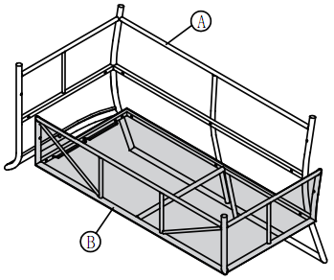

1

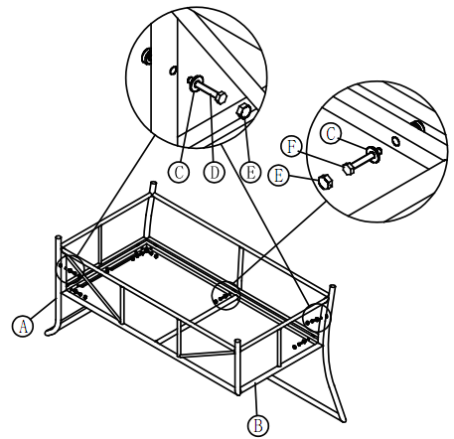

22

32

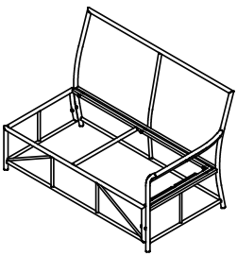

**ASSEMBLY STEPS FOR RIGHT HAND SECTION:**

1. Position part (A)and part (B) ready for assembly
2. With 5 bolts (F) and 5 flat washers (C) LOOSELY attach back piece (A) with spanner (G) to seating section (B) DO NOT TIGHTEN

BOLTS AT THIS STAGE.

1. With 2 bolts (D) and 2 flat washers (C) LOOSELY attach front and rear leg with spanner (G) to seating section (B) DO NOT TIGHTEN
2. BOLTS AT THIS STAGE.
3. Tighten all bolts using the spanner (G) cover all bolts using nut cap (E)
4. Turn it over and place where required.

|  |  |  |  |  |  |  |  |  |  |
| --- | --- | --- | --- | --- | --- | --- | --- | --- | --- |
| **Component’s RIGHT HAND SECTION**  **BEECH 68148145 OR ASH 68135146** | | | |  | **Fixings** | | | | |
| **Parts List** | **Parts Picture** | **Description** | **QTY** | **Part no** | **Parts list** | **Parts Picture** | **Description** | **QTY** | **Part no.** |
| **A** |  | **Backrest with RH arm** | **1** | **68148145ARH**  **68135146ARH** | **C** |  | **Big Flat Washers** | **7** | **1061162** |
| **B** |  | **Seating RH Section** | **1** | **68148145BRH**  **68135146BRH** | **D** |  | **M6*50 bolts** | **2** | **2002176** |
|  |  |  |  |  | **E** |  | **Nut cap** | **7** | **2002170** |
|  |  |  |  |  | **F** |  | **M6*45 bolts** | **5** | **2002167** |
|  | | | | | **G** |  | **Spanner** | **1** | **1020162** |

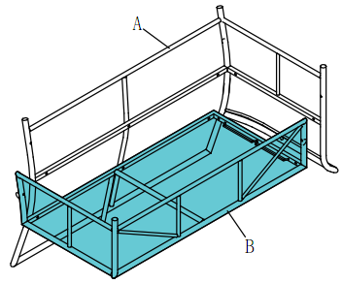

1

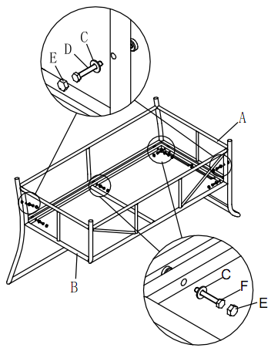

22

32

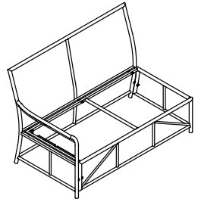

**ASSEMBLY STEPS FOR CORNER SECTION:**

1. Position part (A)and part (B) ready for assembly
2. With 4 bolts (F) and 4 flat washers (C) LOOSELY attach back piece (A) with spanner (G) to seating section (B) DO NOT TIGHTEN

BOLTS AT THIS STAGE.

1. With 2 bolts (D) and 2 flat washers (C) LOOSELY attach 2 legs with spanner (G) to seating section (B) DO NOT TIGHTEN
2. BOLTS AT THIS STAGE.
3. Tighten all bolts using the spanner (G) cover all bolts using nut cap (E)
4. Turn it over and place where required.

|  |  |  |  |  |  |  |  |  |  |
| --- | --- | --- | --- | --- | --- | --- | --- | --- | --- |
| **Component’s CORNER SECTION**  **BEECH 68148145 OR ASH 68135146** | | | |  | **Fixings** | | | | |
| **Parts List** | **Parts Picture** | **Description** | **QTY** | **Part no** | **Parts list** | **Parts Picture** | **Description** | **QTY** | **Part no.** |
| **A** |  | **Backrest** | **1** | **68148145AC**  **68135146AC** | **C** |  | **Big Flat Washers** | **5** | **1061162** |
| **B** |  | **Seating Section** | **1** | **68148145BC**  **68135146BC** | **D** |  | **M6*50 bolts** | **2** | **2002176** |
|  |  |  |  |  | **E** |  | **Nut cap** | **5** | **2002170** |
|  |  |  |  |  | **F** |  | **M6*45 bolts** | **3** | **2002167** |
|  | | | | | **G** |  | **Spanner** | **1** | **1020162** |

22

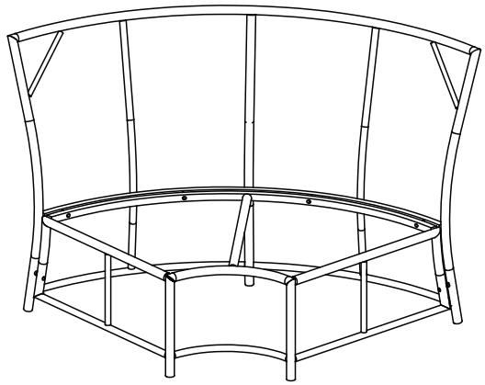

**ASSEMBLY STEPS CONNECTING SOFAS:**

1. Position part (A1) and part (B1) ready for assembly
2. With brackets (D1) position over the section that adjoin parts (A1) and (B1). Diagram 2.
3. Turn sofas over and place where required
4. Put all cushions on the sofa

|  |  |  |  |  |  |  |  |  |  |
| --- | --- | --- | --- | --- | --- | --- | --- | --- | --- |
| **Component’s CONNECTING SOFAS** | | | |  | **Fixings** | | | | |
| **Parts List** | **Parts Picture** | **Description** | **QTY** | **Part no** | **Parts list** | **Parts Picture** | **Description** | **QTY** | **Part no.** |
| **A1** |  | **Corner sofa** | **1** | **n/a** | **D1** |  | **Bracket** | **4** | **2002189** |
| **B1** |  | **RH Sofa** | **1** | **n/a** |  |  |  |  |  |
| **C1** |  | **LH Sofa** | **1** | **n/a** |  |  |  |  |  |

